The following requests were created through the “Postman”.

Trello API documentation - <https://developer.atlassian.com/cloud/trello/rest/api-group-boards>

Board:

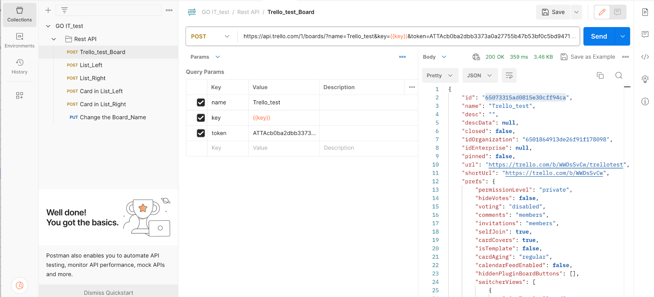

1) A column is created on the board on the left, in the documentation, the section is called "Create a new List", add tests: to check the status of the code; to check the request time; to check that the value “name” is a string;

Params in Postman:

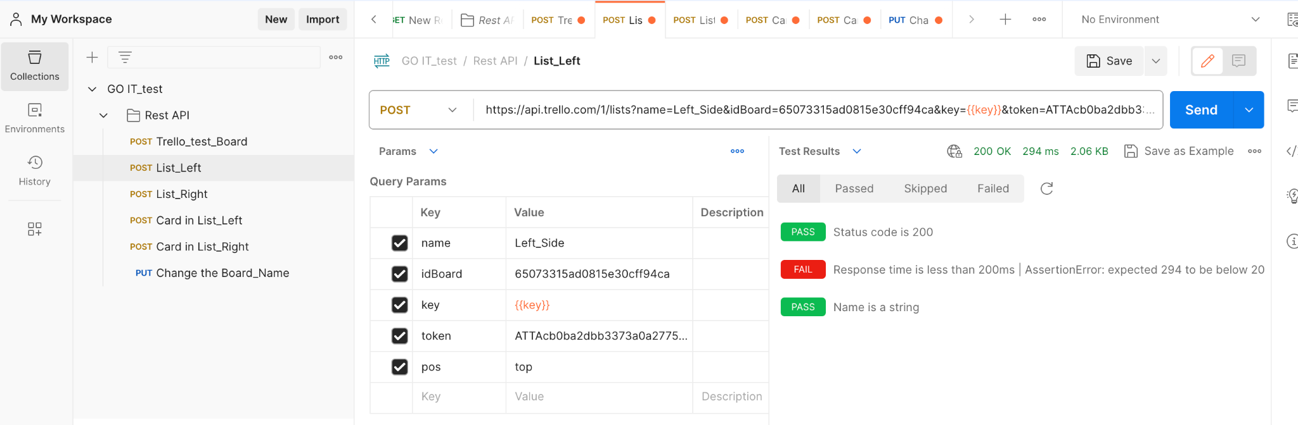

Tests in Postman:

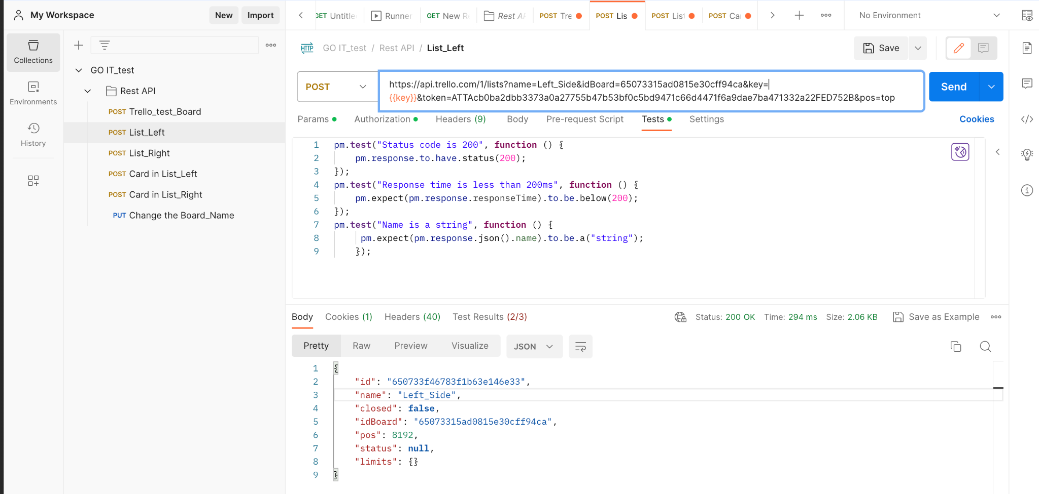

2) A column is created on the board on the right, in the documentation, the section is called "Create a new List", add tests: to check the status of the code; to check the request time; to check that the value “name” is a string;

Params in Postman:

Params in Postman:

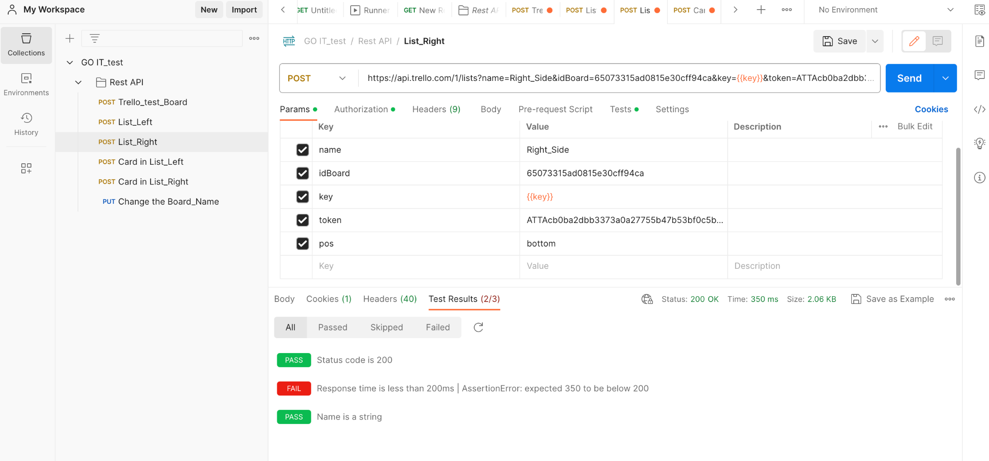

Tests in Postman:

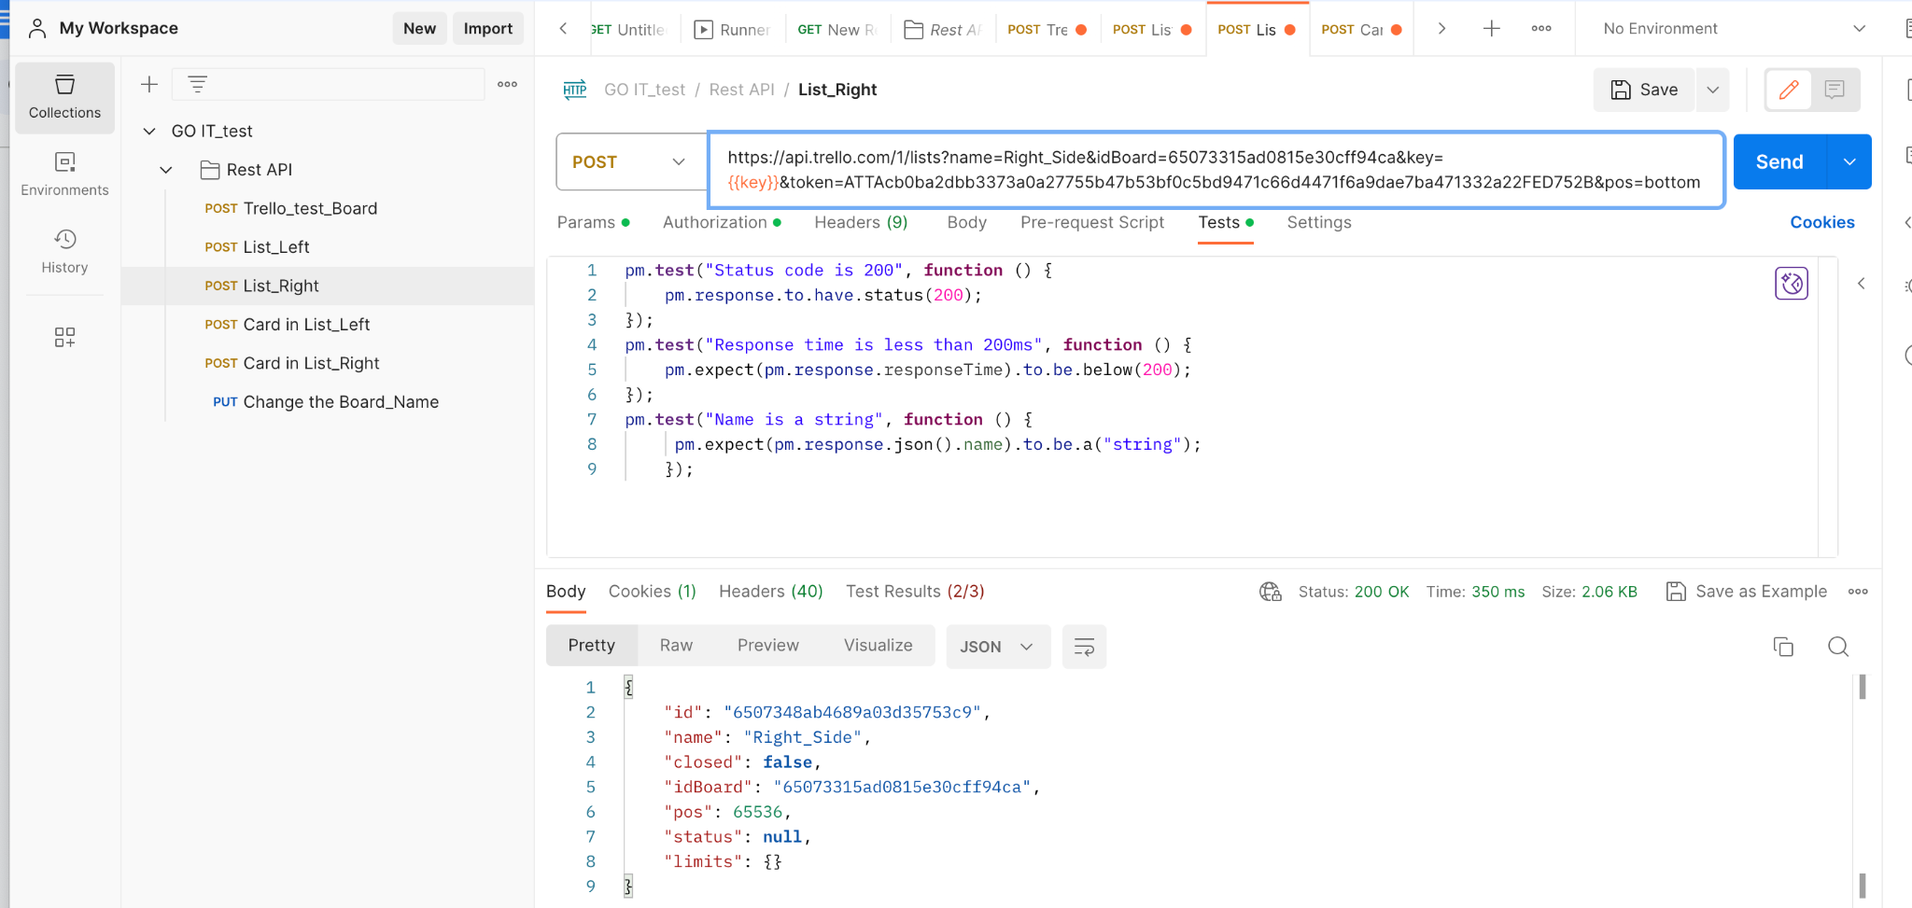

3) One card was created in each of the columns that were created in tasks 1 and 2 on the board (2 cards in total), in the documentation, the section is called “Create a new Card”, in the requests for creating cards, add tests: to check the status of the code ; to check the request time; to check that the value of "id" is a string;

Params in Postman:

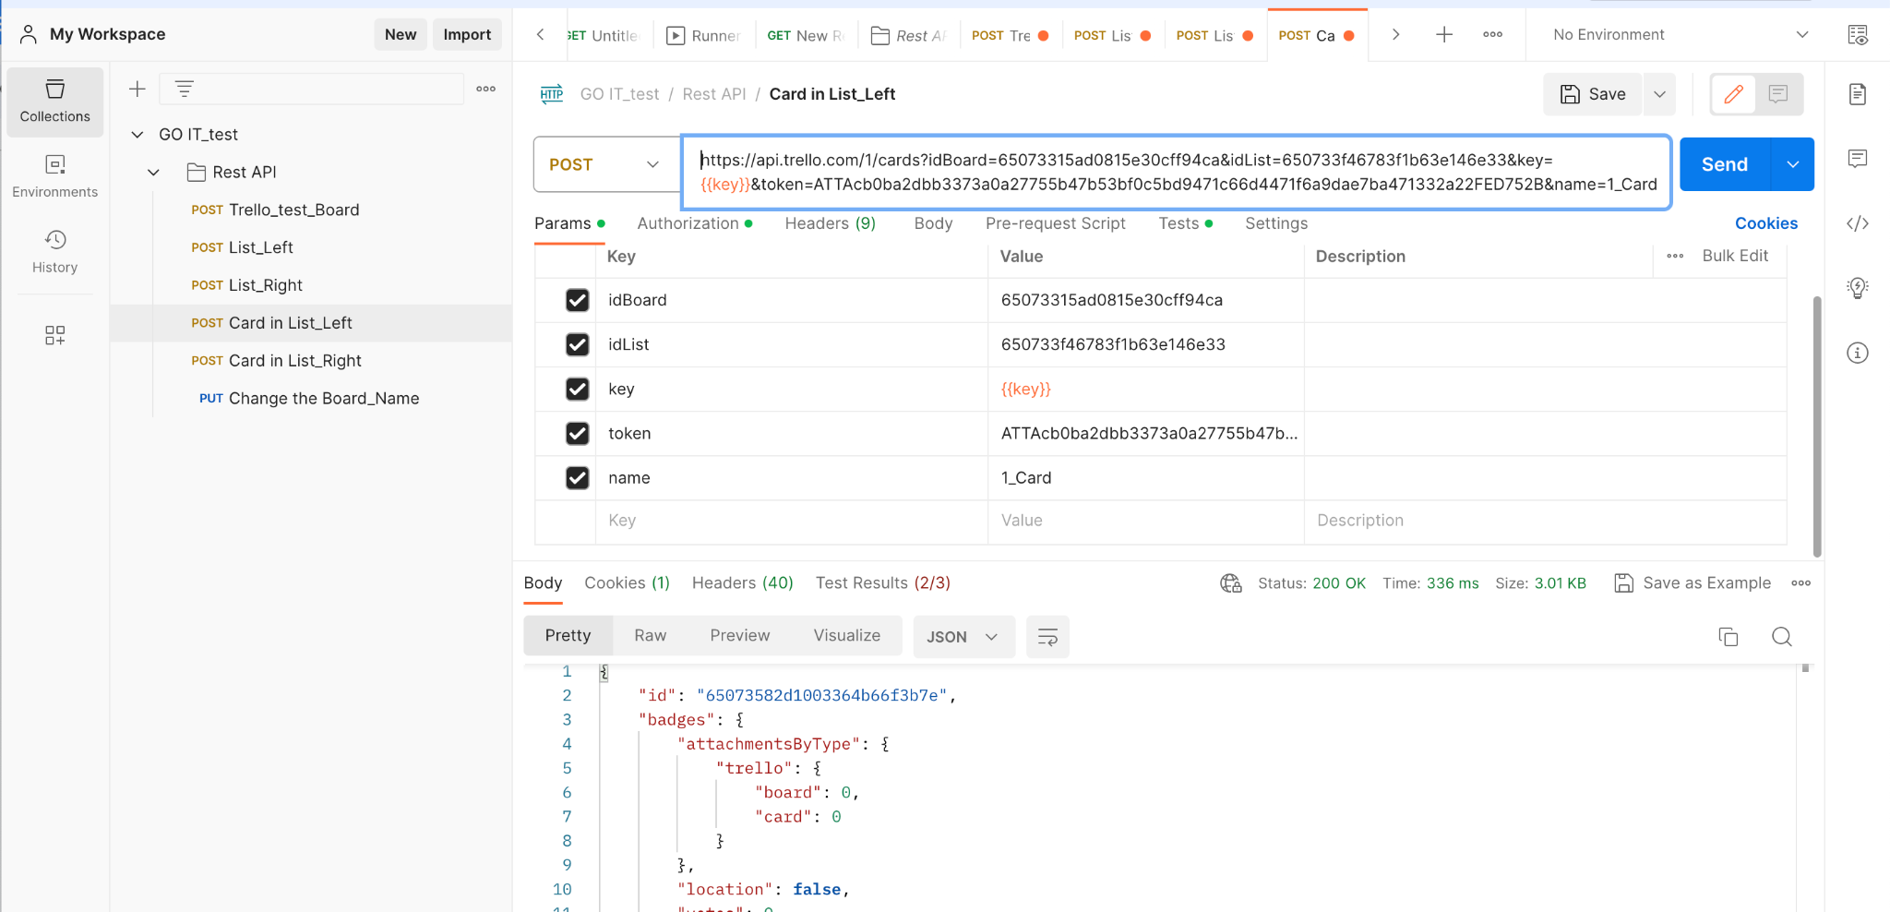

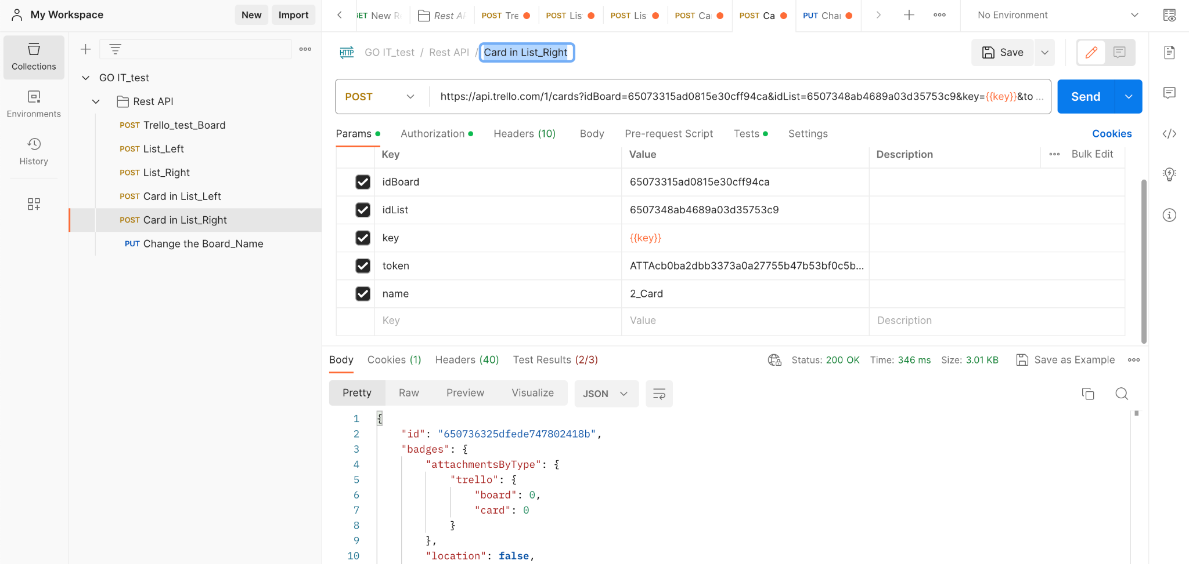

Tests in Postman:

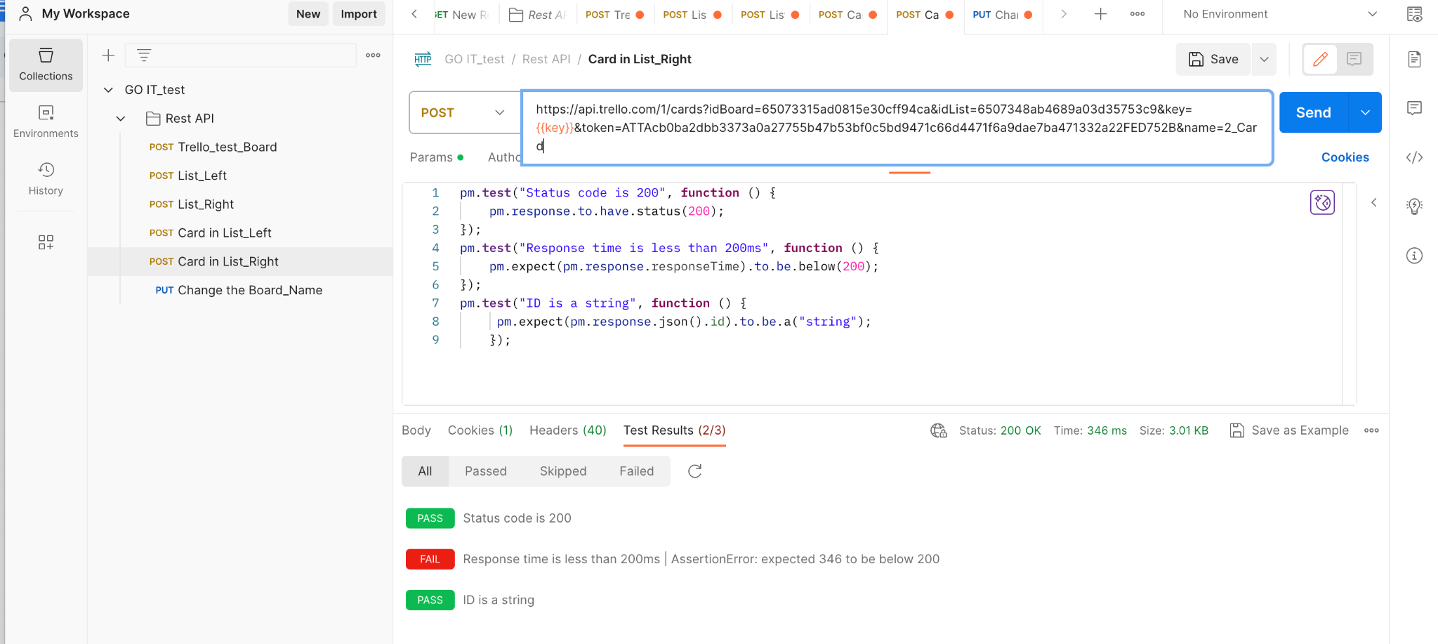

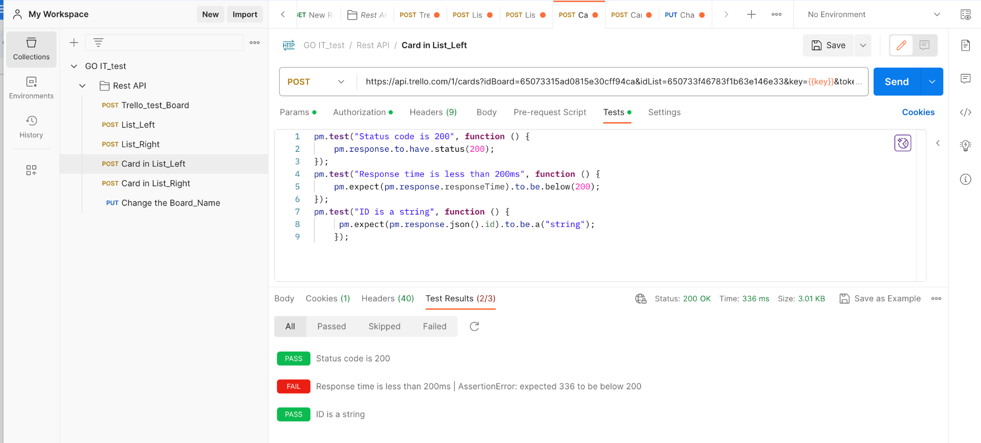

Result in Trello:

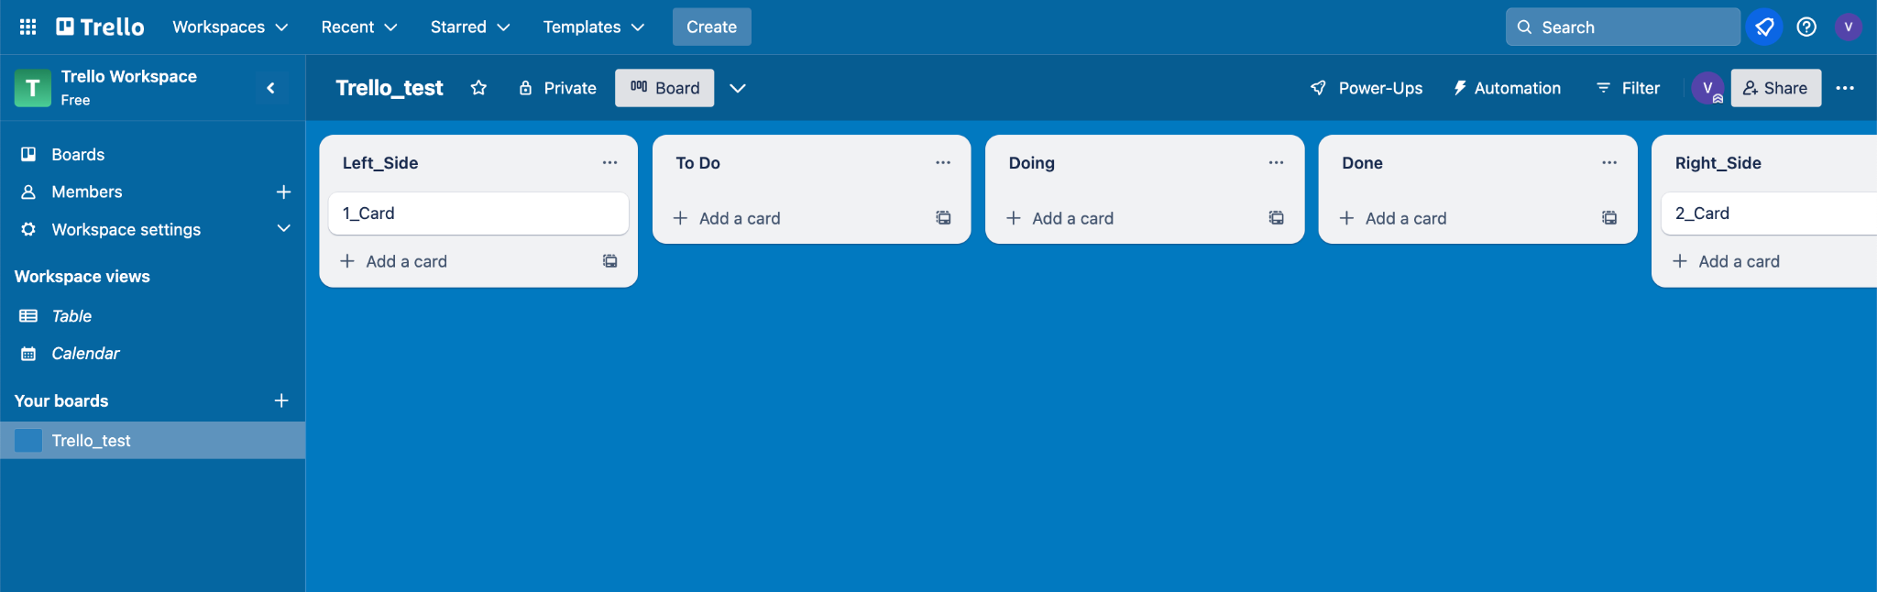

4) Information about the created board has been updated, in the documentation the section is called "Update a Board", the name of the board has been changed, add a description of the board, add tests: to check the status of the code; to check the request time.

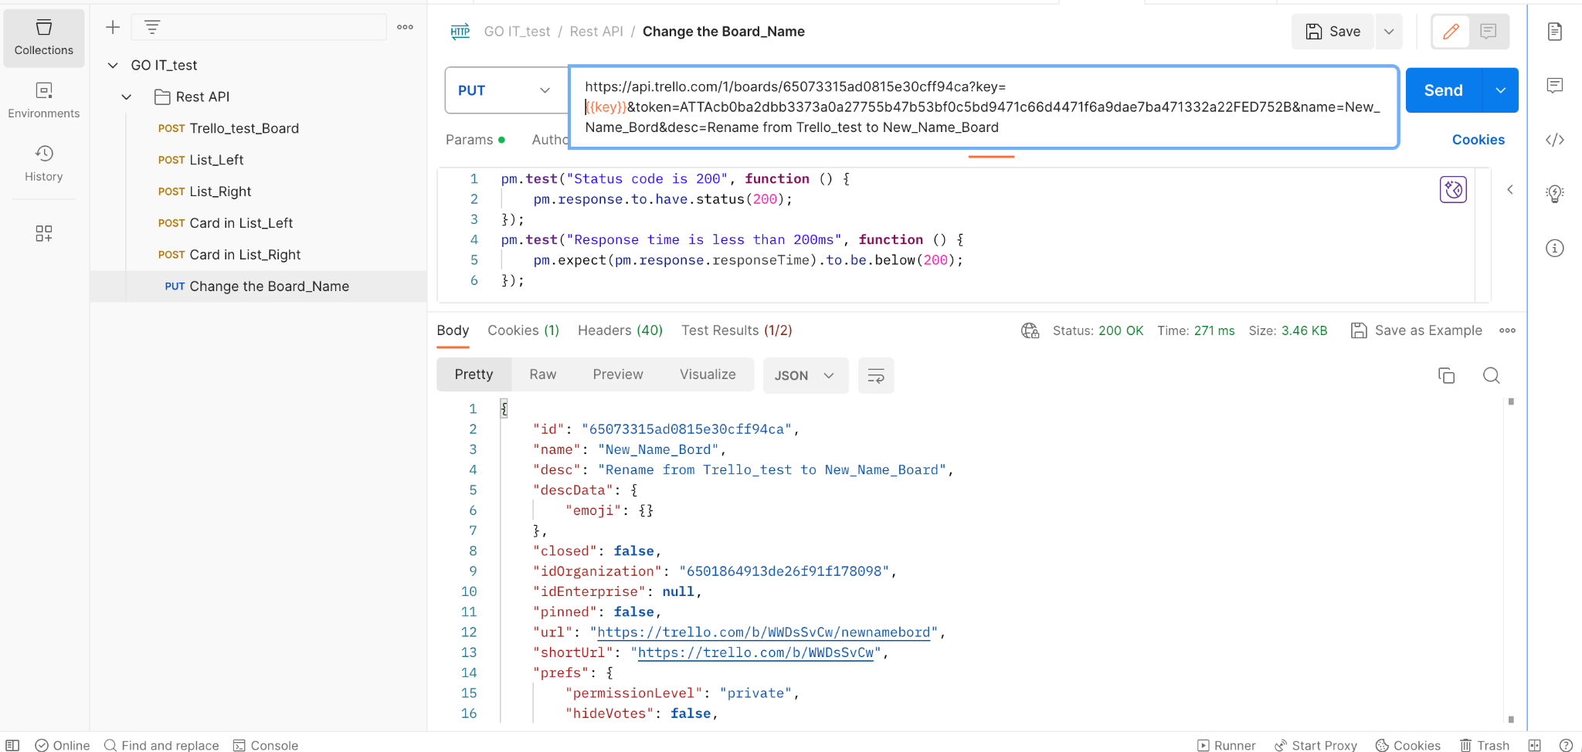

Result in Trello:

